ResortHub – Resort Booking & Live Support System

1. Purpose
The Resort Booking & Real-time Chat System is developed to:
- Provide an online resort booking platform for customers.
- Allow customers to submit booking requests and track booking status.
- Enable resort staff to approve or reject booking requests.
- Provide a real-time chat feature between customers and resorts for each booking.
- Support administrators in monitoring and managing the entire system.
Main objective of the system is:
- Optimize the booking process
- Reduce manual operations
- Increase transparency
- Improve customer experience

2. Scope

2.1 In-scope

Customer:
- Register an account via OTP verification
- Log in / Log out
- Create a booking
- Cancel a booking (if it has not been approved)
- Chat with Staff and Owner when booking a resort
- Manage personal profile
- Search, filter, sort, and paginate the resort list
- View resort details
- Make payments via ATM / Online Banking
- Create a lost item report

Staff:
- Approve resorts
- Suggest resort modifications
- Create contracts
- Handle lost item reports
- Chat with customers

Owner:
- Register a resort
- Manage their own resorts
- Manage bookings (Accept / Reject bookings)
- Chat with customers
- View dashboard including total revenue and average rating
- Create contracts with customers

Admin:
- Manage users
- Assign roles and permissions
- Manage all resorts
- View total revenue, growth rate, and total number of users

2.2 Out of Scope
- AI Chat and Recommendations

3.Context Diagram

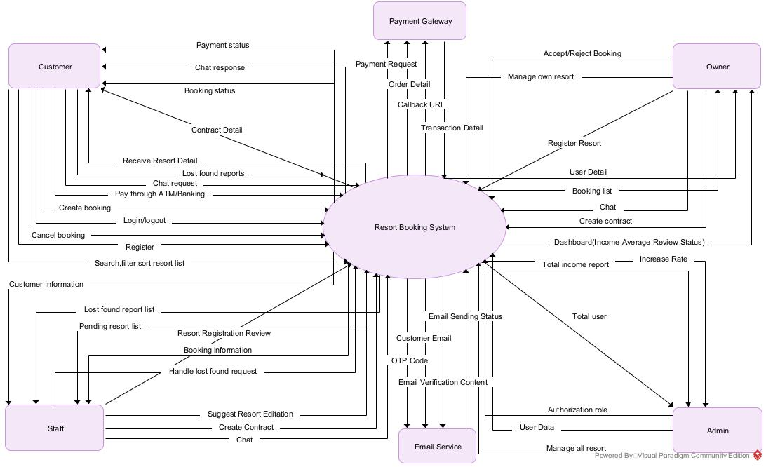

4.Functional Requirements

4.1 FR-Customer
- FR-C1: The system allows customers to register an account with OTP verification via Email Service.
- FR-C2: The system allows customers to log in and log out.
- FR-C3: The system allows customers to search, filter, and sort resorts.
- FR-C4: The system allows customers to view resort details.
- FR-C5: The system allows customers to create a booking.
- FR-C6: The system allows customers to cancel a booking if it has not yet been approved.
- FR-C7: The system automatically cancels a booking if it remains in Pending status beyond the specified time limit.
- FR-C8: The system allows customers to make payments via a Payment Gateway.
- FR-C9: The system displays the payment status.
- FR-C10: The system allows customers to chat with Staff or Owners.
- FR-C11: The system allows customers to create a lost item report.

4.2 FR-Staff
- FR-S1: The system shall allow Staff to evaluate submitted resort registrations and approve or reject them.
- FR-S2: The system shall allow Staff to provide feedback and request updates to resort details before approval.
- FR-S3: The system shall allow Staff to generate and manage contracts with Owners once a resort is approved.
- FR-S4: The system shall allow Staff to review, update, and resolve lost item reports submitted by customers.
- FR-S5: The system shall enable real-time communication between Staff and customers.

4.3 FR – Owner
- FR-O1: The system shall allow the Owner to submit resort registration information for review.
- FR-O2: The system shall allow the Owner to update, edit, and manage resort details.
- FR-O3: The system shall allow the Owner to approve or reject pending bookings.
- FR-O4: The system shall allow the Owner to generate and manage contracts with customers after booking approval.
- FR-O5: The system shall provide a dashboard showing revenue statistics and average customer ratings.

4.4 FR – Admin
- FR-A1: The system shall allow the Admin to create, update, deactivate, and delete user accounts.
- FR-A2: The system shall allow the Admin to assign, modify, and revoke user roles.
- FR-A3: The system shall allow the Admin to view, update, and remove any resort listed in the system.
- FR-A4: The system shall generate and display comprehensive revenue reports.
- FR-A5: The system shall provide statistical reports including total users and growth trends over time.

5.Non-functional Requirements

5.1 Performance
- NFR-P1: The system shall maintain an average API response time of less than 3 seconds for 95% of requests under normal load conditions.
- NFR-P2: The system shall support a minimum of 200 concurrent users while maintaining acceptable performance levels.

5.2 Security
- NFR-S1: The system shall store all user passwords using a secure hashing algorithm (e.g., BCrypt).
- NFR-S2: The system shall authenticate users using JWT-based authentication mechanisms.

- NFR-S3: The system shall restrict system access based on predefined user roles (Customer, Staff, Owner, Admin).

5.3 Reliability
- NFR-R1: The system shall automatically back up all critical data at least once every 24 hours.
- NFR-R2: The system shall ensure a minimum availability (uptime) of 99% over a one-month period.

5.4 Usability
- NFR-U1: The system shall ensure that the user interface is fully responsive and compatible with modern web browsers on both mobile and desktop platforms.
- NFR-U2: The system shall ensure that users can complete the booking process in a maximum of five steps to enhance usability and user experience.

5.5 Scalability
- NFR-SC1: The system architecture shall allow for future expansion to support increased resort listings and user traffic without requiring major system redesign.

6.Use Case

6.1 Actors
STT | Actors | Description
1 | Customer | Customer who uses the resort booking service.
2 | Staff | Staff who reviews and processes resort and booking-related documents.
3 | Owner | Owner who manages and rents out resorts.
4 | Admin | Manage and maintain the system.
5 | Payment Gateway (external system) | External system used to process online payments.
6 | Email Service (external system) | Email service used to send and verify OTP codes.

6.2 Use Case
STT | Use Case | Actor
1 | Register Account | Customer
2 | Verify OTP | Customer
3 | Login | Customer
4 | Logout | Customer
5 | Search,Filter,Sort Resort | Customer
6 | View Resort Details | Customer
7 | Create Booking | Customer
8 | Cancel Booking | Customer
9 | Make Payment | Customer
10 | Chat with Staff/Owner | Customer
11 | Report Lost Found items | Customer
12 | View Booking Status | Customer
13 | Approve/Reject Resort | Staff
14 | Suggest Resort Modification | Staff
15 | Create Contract With Owner | Staff
16 | Process Lost Item Report | Staff
17 | Chat with Customer | Staff
18 | Register Resort | Owner
19 | Manage Own Resort | Owner
20 | Approve/Reject Booking | Owner
21 | Create Contract with Customer | Owner
22 | View Revenue Dashboard | Owner
23 | Chat with Customer | Owner
24 | Manage Users | Admin
25 | Assign Roles | Admin
26 | Manage All Resorts | Admin
27 | View System Revenue Report | Admin
28 | View Growth Statistics | Admin
29 | Process Payment | Payment Gateway
30 | Send OTP Email | Email Service
31 | Send Notification Email | Email Service

6.3 Use Case Diagram
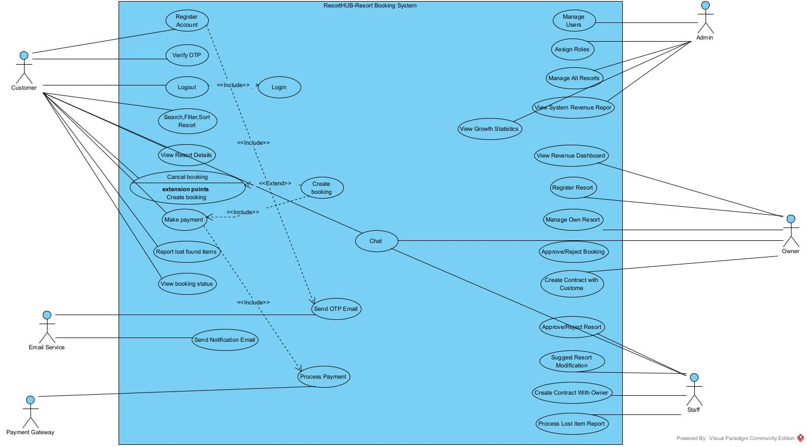

7. ERD Schema
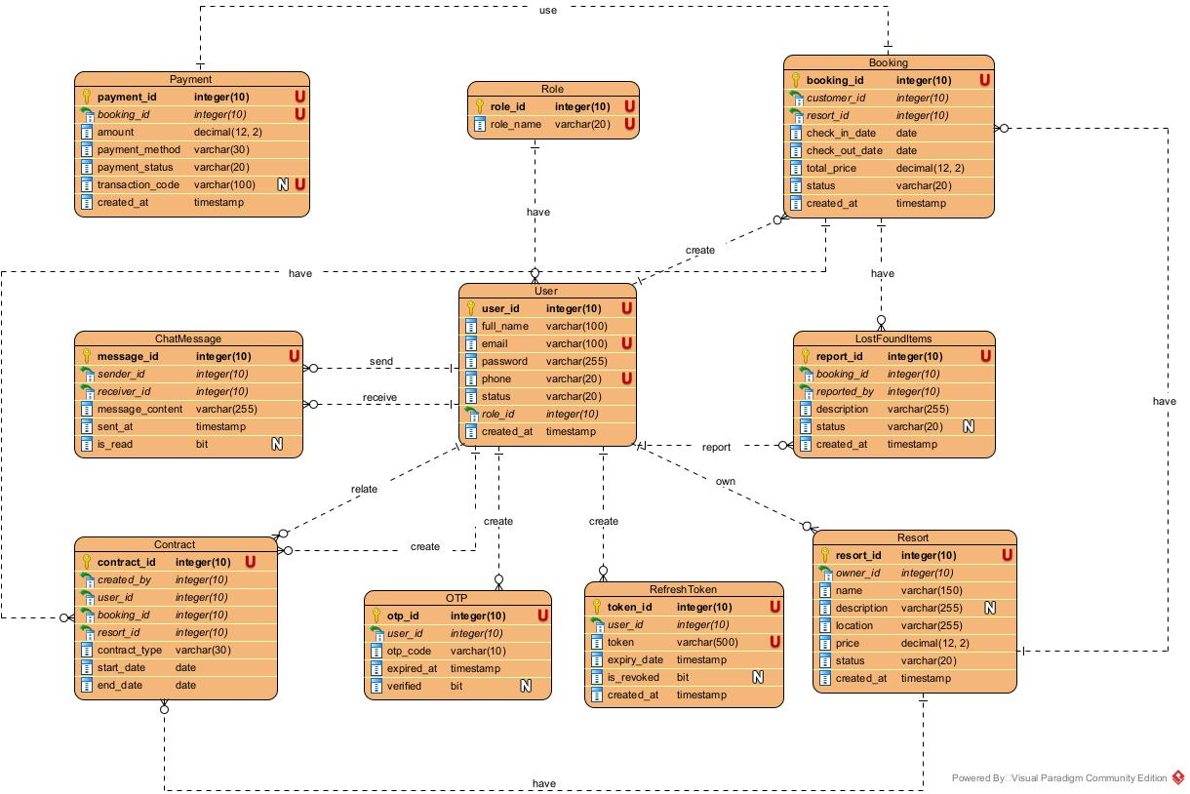
//Sua lai timestamp thanh DATETIME2
//Sua user_id o contract thanh related_to

8. API Design

8.1 Auth Module

STT | API | Purpose
1 | POST /api/auth/register | Register account
2 | POST /api/auth/verify-otp | Verify OTP
3 | POST /api/auth/login | Login account
4 | POST /api/auth/refresh-token | Give new token when old token is expired
5 | POST /api/auth/logout | Logout account

8.2 User module(Admin)

STT | API | Purpose
1 | GET /api/admin/users | View the user list with pagination and filter and search
2 | PUT /api/admin/users/{id} | Update user information
3 | DELETE /api/admin/users/{id} | Inactive or delete user account
4 | PATCH /api/admin/users/{id}/role | Insert,update and retrieve the user role

8.3 Resort Module

STT | API | Purpose
1 | POST /api/owner/resorts | Register new resort for staff to review
2 | PATCH /api/staff/resorts/{id}/status | Accept or reject resort after review
3 | GET /api/resorts | View resort list that is accepted
4 | GET /api/staff/resorts | View resort list that is accepted and rejected
5 | GET /api/resorts/{id} | View resort detail

8.4 Booking module

STT | API | Purpose
1 | POST /api/customer/bookings | Allow customer booking resort
2 | DELETE /api/customer/bookings/{id} | Cancel booking if it not approve by owner
3 | PATCH /api/owner/bookings/{id}/status | Allow owner to accept or reject the booking in status =”PENDING”
4 | GET /api/customer/bookings | Allow customer to see booking list to view status

8.5 Payment module

STT | API | Purpose
1 | POST /api/customer/payments | Generate payment process and navigate to payment gateway
2 | POST /api/payments/callback | Receive payment result and update payment status
3 | GET /api/customer/payments/{id} | Allow customer check payment status of one booking

8.6 Chat Module
WebSocket Generate: /ws/chat : Generate real-time connection between customer and owner and staff
Booking chat topic channel:
- /topic/booking/{bookingId}
- /topic/resort/{resortId}
STT | API | Purpose
1 | GET /api/chat/booking/{bookingId} | Get booking chat history
2 | GET /api/chat/resort/{resortId} | Get resort chat history

8.7 Contract Module

STT | API | Purpose
1 | POST /api/staff/contracts | Allow Staff to create a contract between the system and the Owner after a resort has been approved.
2 | POST /api/owner/contracts | Allow the Owner to create a contract with the Customer after a booking has been approved.

8.8 Lost item report module

STT | API | Purpose
1 | POST /api/customer/lost-items | Allow customers to submit a lost item report related to a specific booking.
2 | PATCH /api/staff/lost-items/{id} | Allow staff to process and update the status of a lost item report.

8.9 Dashboard module

STT | API | Purpose
1 | GET /api/owner/dashboard | Provide owner with revenue statistics and performance metrics related to their resorts.
2 | GET /api/admin/dashboard | Provide a comprehensive system overview for administrators.

